* **Overview of Software Developments Tools :**
* Source Control ( GIT , TFS, SVN )
* IDE ( Visual Studio , Eclipse , InteliJ)
* CICD ( Jenkins )
* Scans ( Sonar Qube , Black Duck , ThreadFix )
* Sql Server Management Studio for Oracle DB / MS DB
* Notepad++
* **Git basics**

Git is a free and open-source version control system, originally created by Linus Torvalds in 2005. Unlike older centralized version control systems such as SVN and CVS, Git is distributed: every developer has the full history of their code repository locally. This makes the initial clone of the repository slower, but subsequent operations such as commit, blame, diff, merge, and log dramatically faster.

Git also has excellent support for branching, merging, and rewriting repository history, which has led to many innovative and powerful workflows and tools. Pull requests are one such popular tool that allows teams to collaborate on Git branches and efficiently review each other's code. Git is the most widely used version control system in the world today and is considered the modern standard for software development.

* **How Git works**

Here is a basic overview of how Git works:

1. Create a "repository" (project) with a git hosting tool (like Bitbucket)
2. Copy (or clone) the repository to your local machine
3. Add a file to your local repo and "commit" (save) the changes
4. "Push" your changes to your main branch
5. Make a change to your file with a git hosting tool and commit
6. "Pull" the changes to your local machine
7. Create a "branch" (version), make a change, commit the change
8. Open a "pull request" (propose changes to the main branch)
9. "Merge" your branch to the main branch

* **Setting Up Git :**

1. Create account at <https://github.com/>
2. Create Repos.
3. <https://github.com/ashishdsi08/Python-Learnings/tree/feature/AK_Learnings>
4. Clone the repo
5. Download Git for windows from : <https://gitforwindows.org/>
6. Download TortoiseGit from : <https://tortoisegit.org/download/>
7. Go To folder where you want to clone repo Ex: A:\Ashish-GIT , right click and you will option to git clone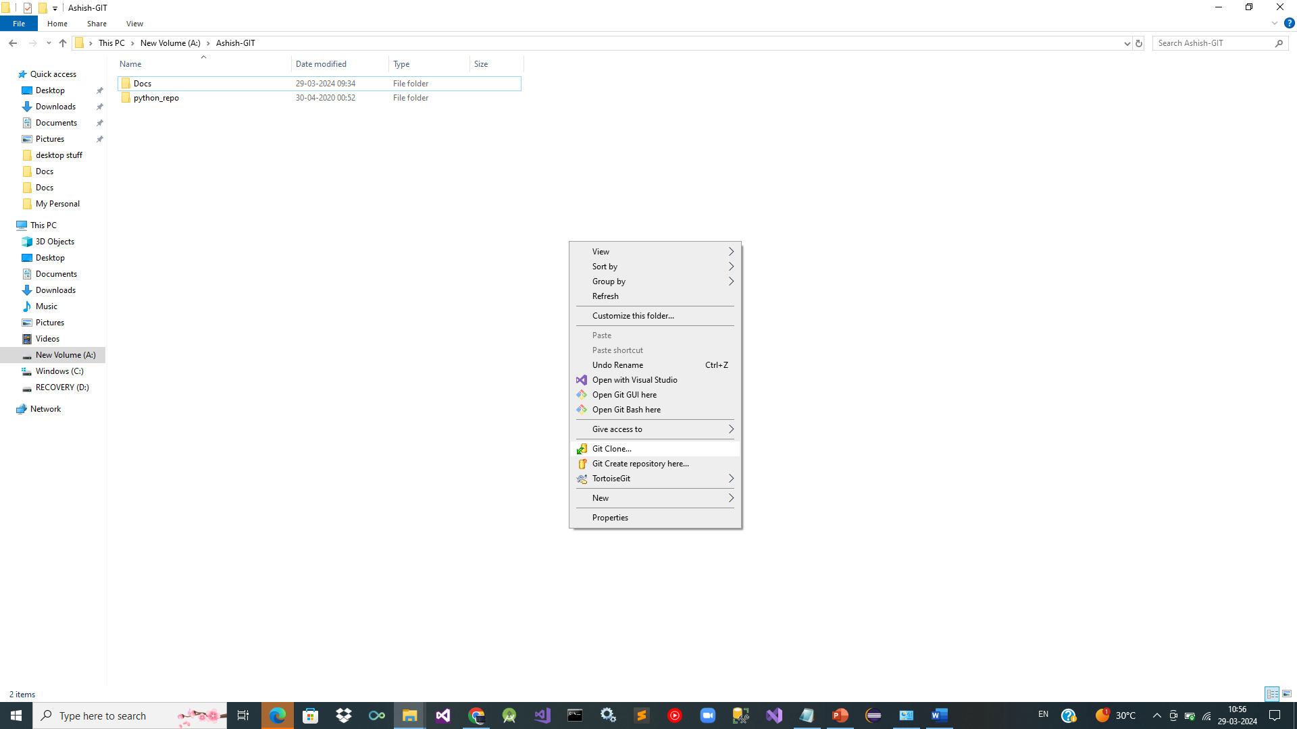

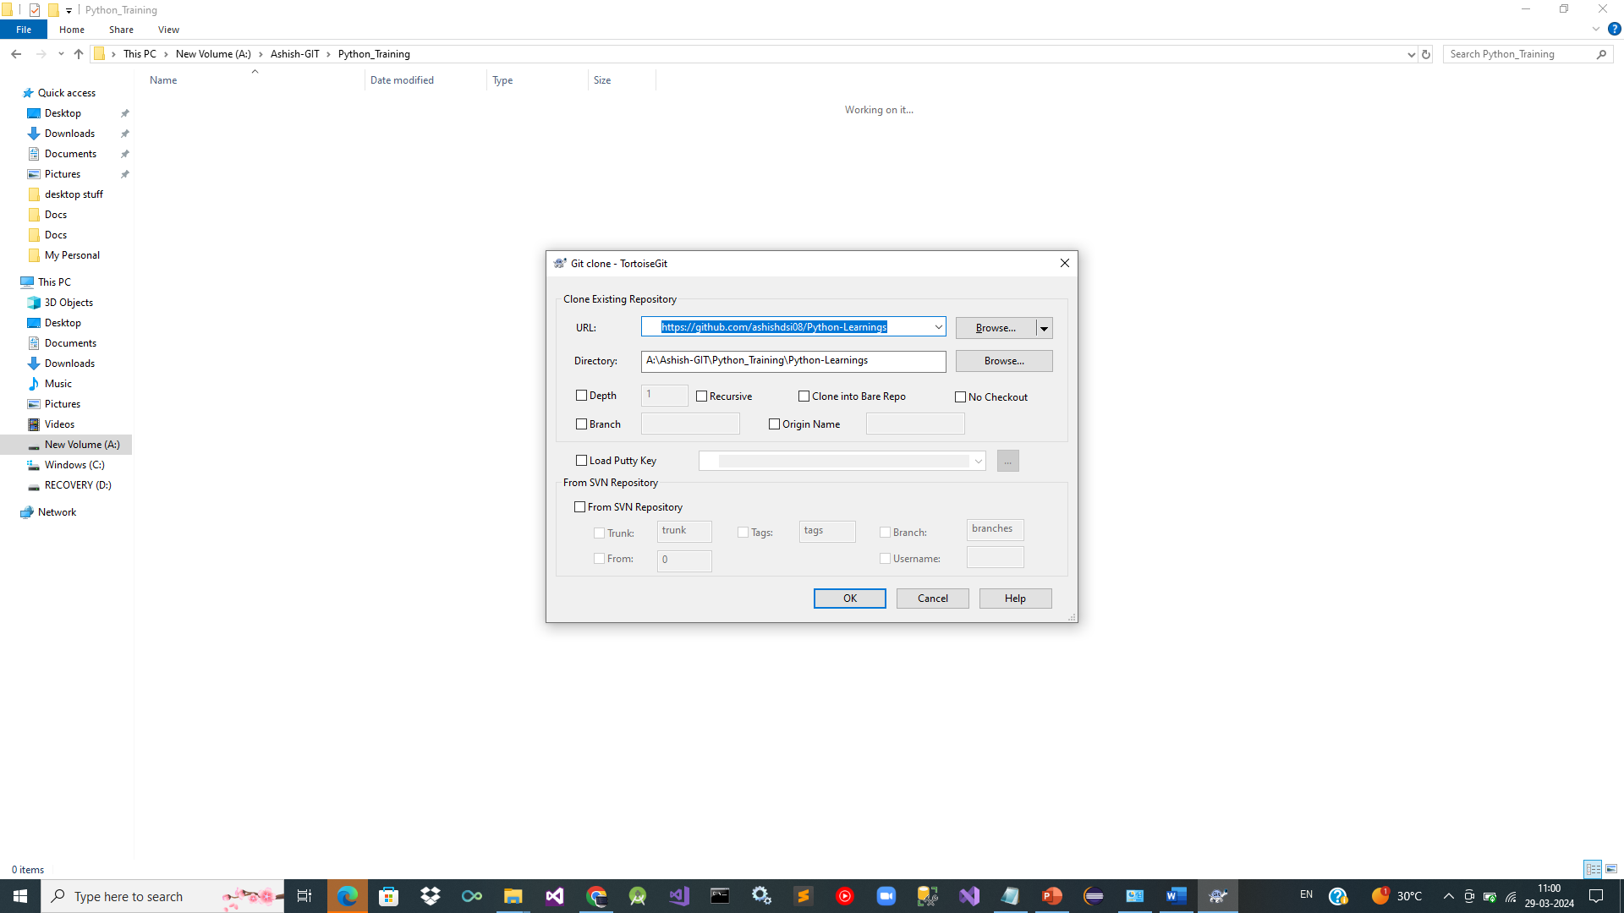

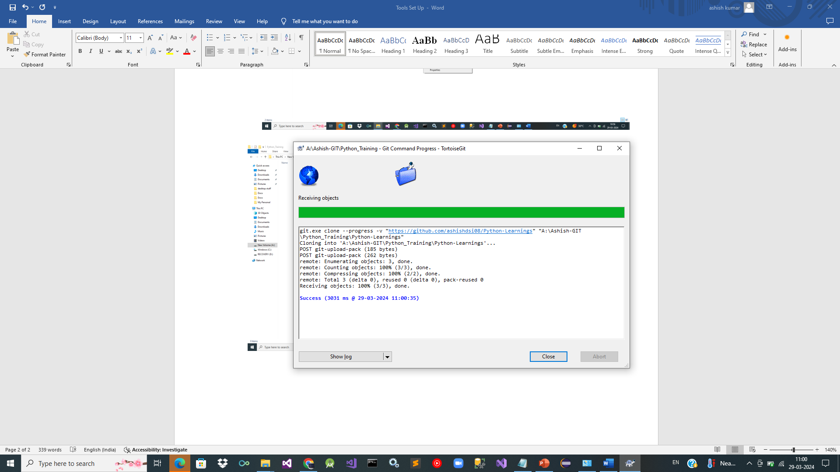

Checkout/Switch : feature branch:

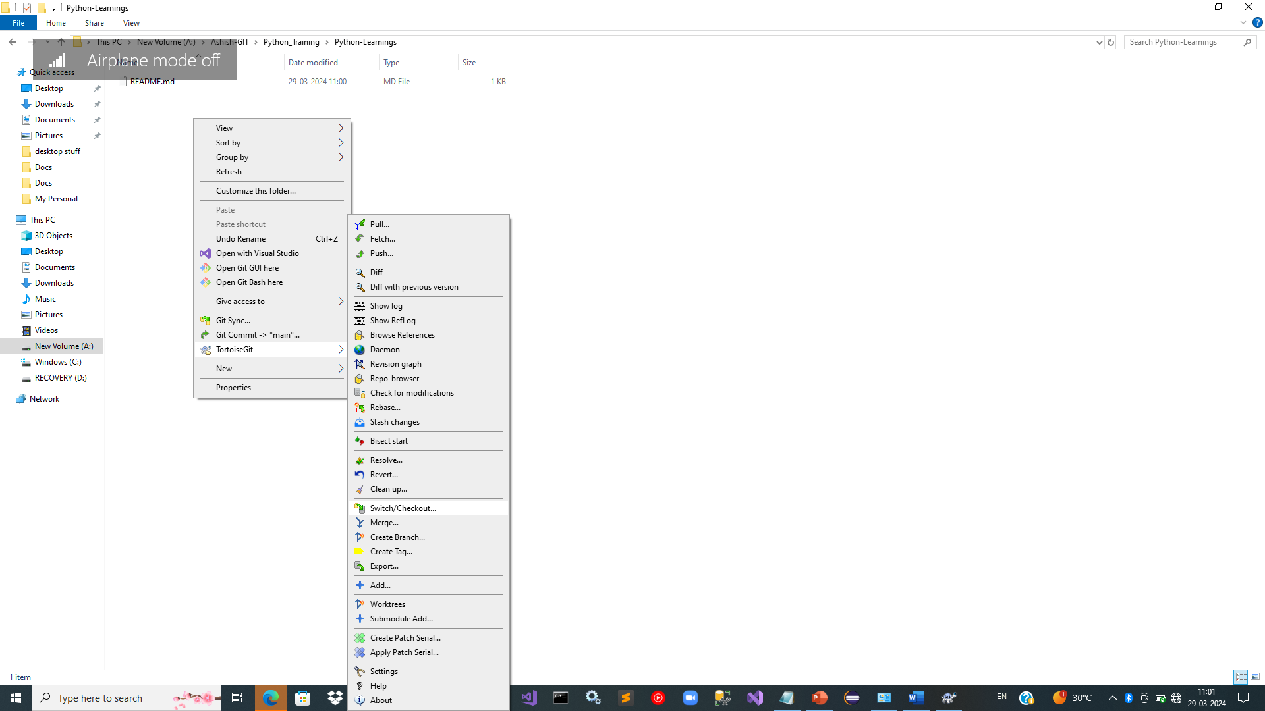

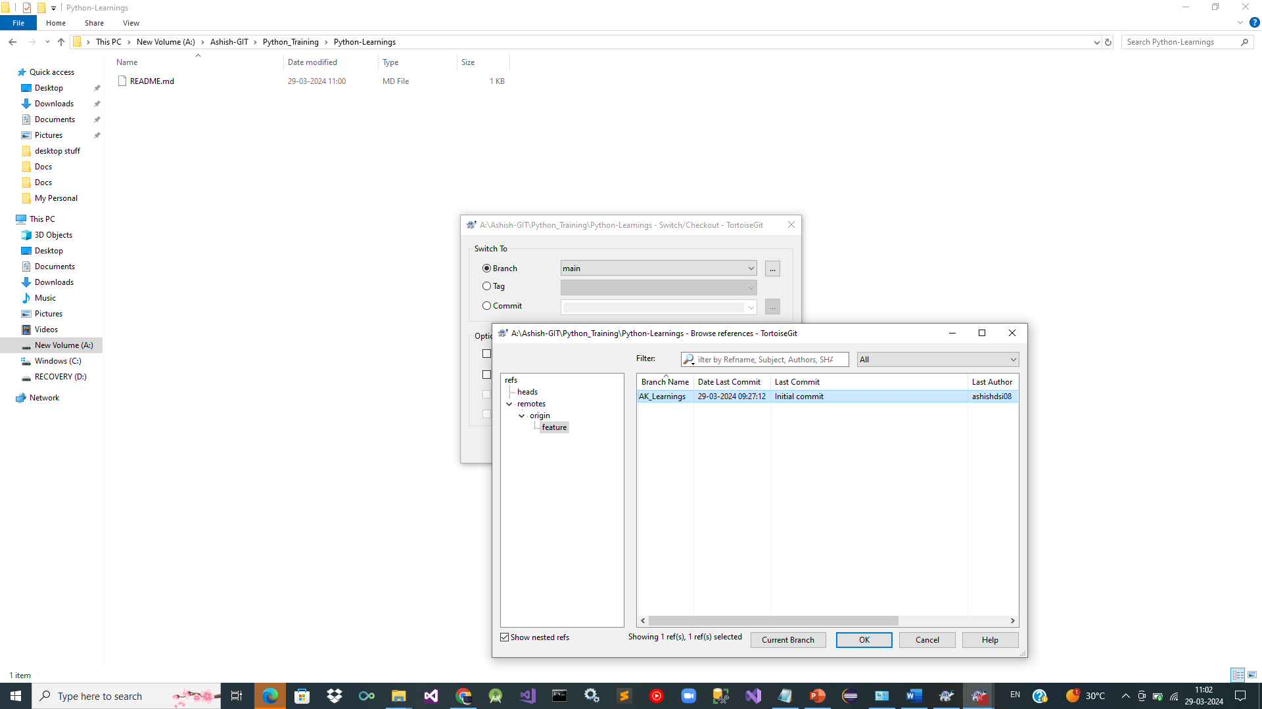

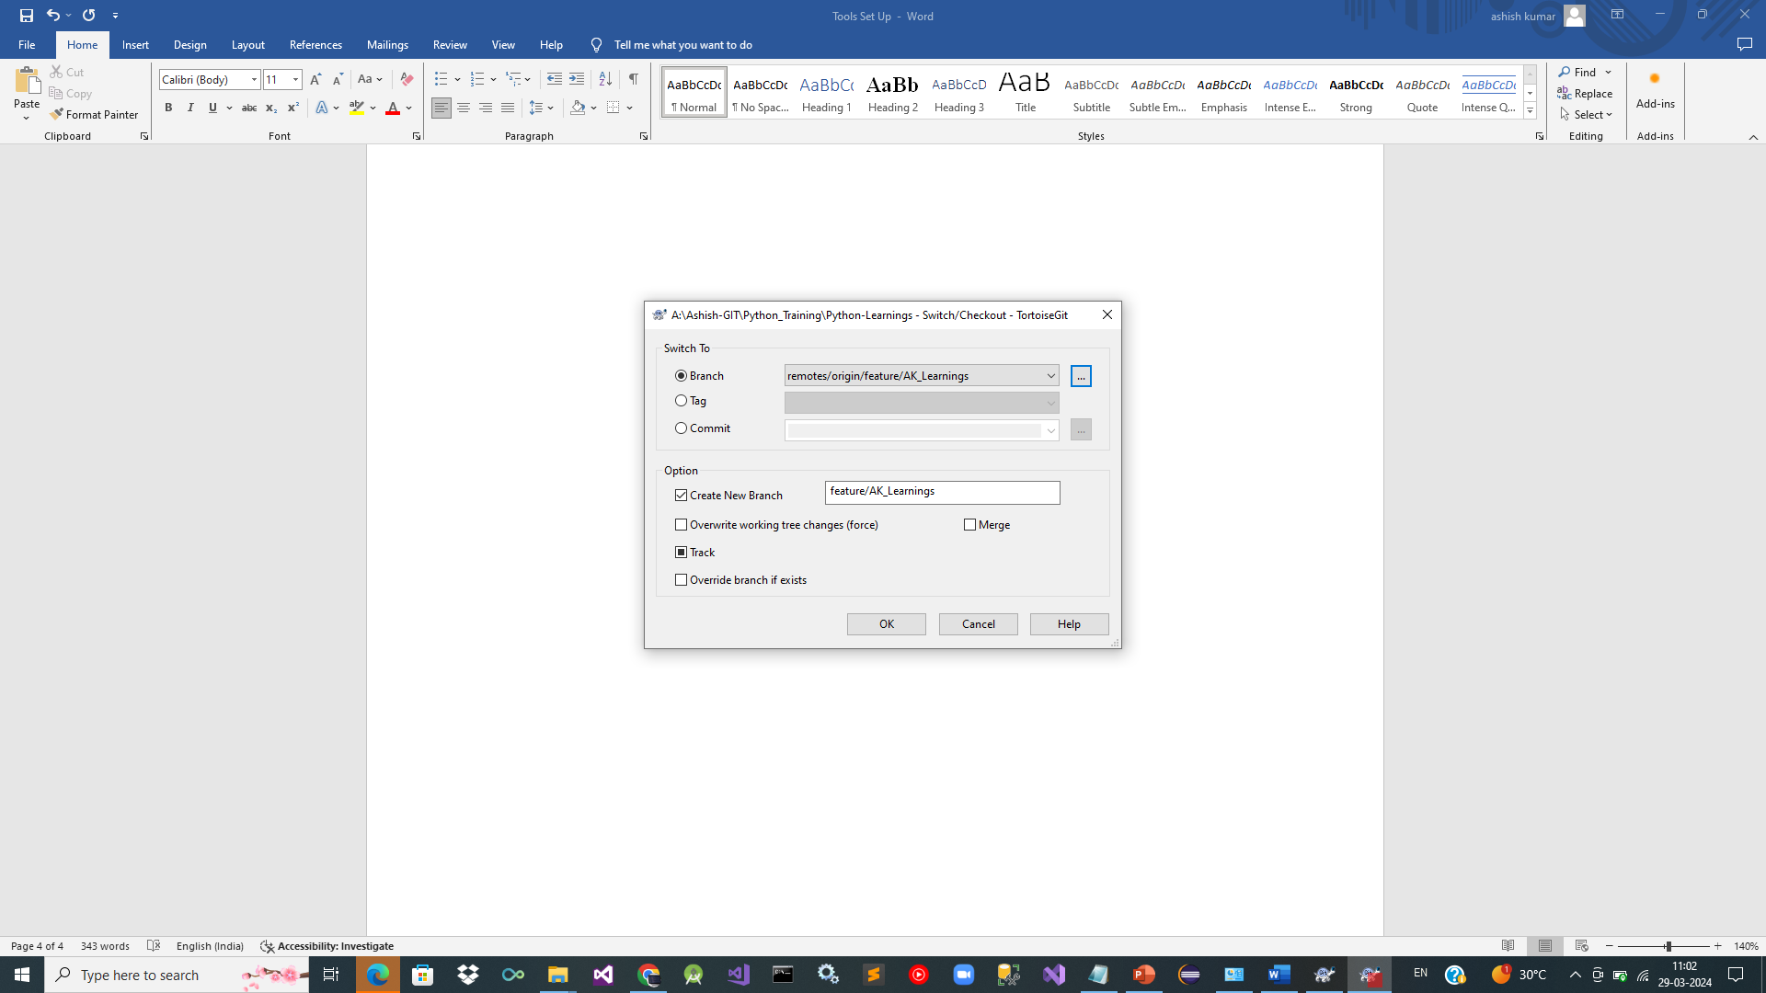

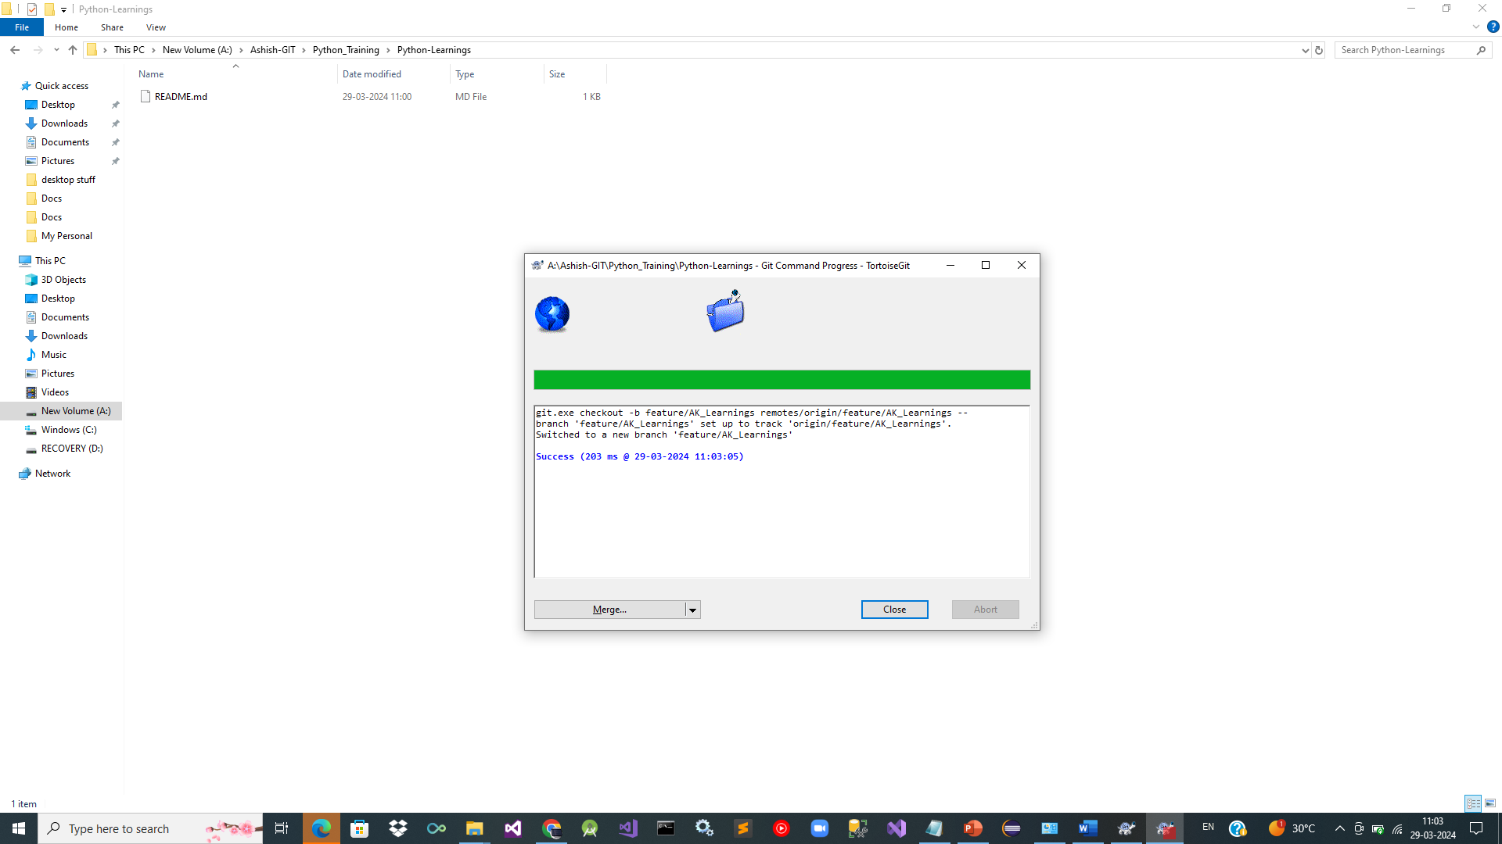

Git checkout of feature branch is done and pulled locally .

Developers can now make changes locally and push to this branch.

Next steps during development is to raise Pull Requests / Reviews .

For release of software all Pull requests from developers is reviewed and merged to develop branch.

Based on branching strategy for the team : release branches are created , builds are prepared and deployed .

* Notepad++ -> Good editor

<https://notepad-plus-plus.org/downloads/>